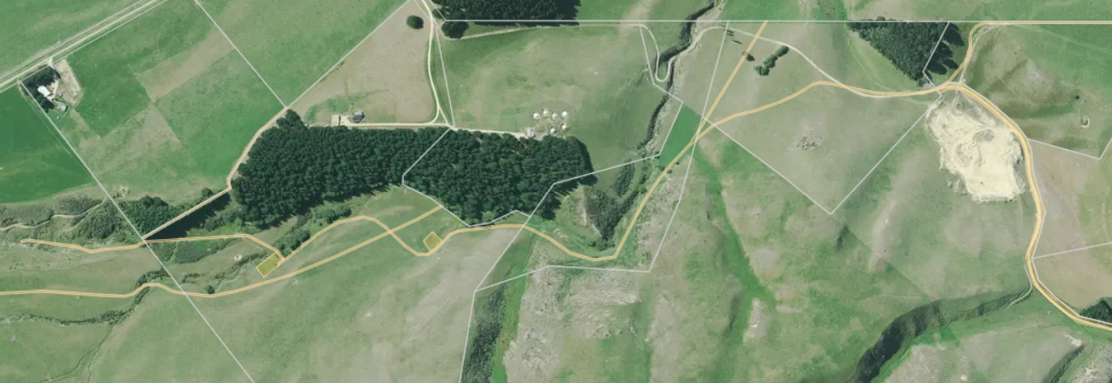
Easements over adjoining land in favour of Lot 17 DP 395170

