2013
80 Byron Street Sydenham
Alterations and additions to existing commercial building - new office/meeting and store room
- TCNA (commercial)
- Liquefaction risk moderate
SUPPORTING DOCUMENT 83pp 250pp
p.56 p.92 Geotechnical letter for proposed extension, EDC, 14 March 2017, signed Gareth Williams (CPEng- geotech)
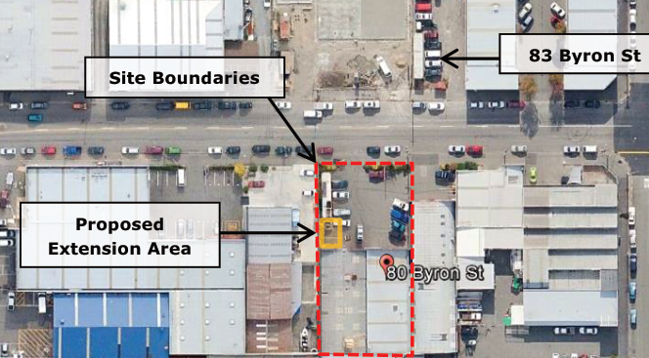
- Proposed fdn concrete slab tied to existing bldg concrete slab
- Geotechnical report for 83 Byron St (40m NE of extension)
  - 2 CPTs, 2 HA
  - Gravel fill to 0.3m, clayey silt to 2.0m consistency?
  - GW not encountered
  - Liquefaction induced settlement 60 – 90mm (SLS2, 10m); 90 – 115mm (ULS, 10m); “very little” in upper 4.5m (SLS or ULS)
  - Lateral spreading risk low
  - Lateral stretch risk minor to moderate
  - Conventional shallow fdn not recommended
  - Piled fdn considered suitable founded at 12.5m; soil between 12 & 16m has sufficient bearing and thickness for deep piles
  - If residential, would be TC3
- Expected profile (from 50m NW of site): 0.8m fill, silt with occ sand to 4.5m, fine to med sand to ≥ 15m
- GW 0.0 – 2.0m (GNS); 1.0 – 2.0m (EQC)
- Vert ground movement 100 – 200mm from CEQ (EQC)
- Horiz ground movement 170mm to SW (EQC)
- No liq ejecta observed after CES
- No ground cracks on site or nearby (EQC)
- Site sufficiently tested to SLS
- Damage to existing bldg was light and limited
- Class D deep or soft soil
- FFL 14.39m; avg ground level on site 13.82m
- 2 HA to 3.2m, 2 Scala to 2.9 – 3.9m
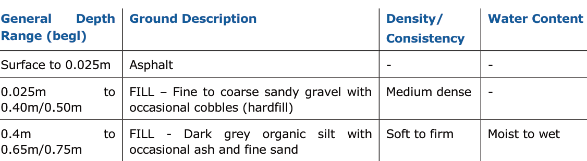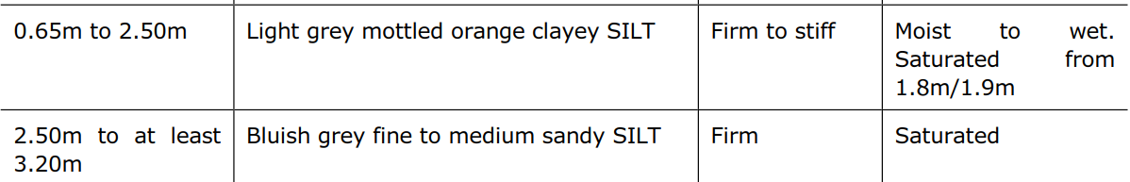
- GW 1.6m
- Hydrocarbon smell at HA102 at 1.0m
- 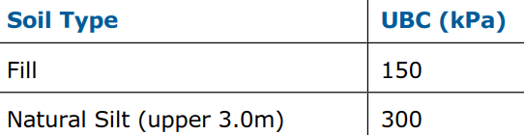
- Proposed slab on grade suitable fdn
- 300mm layer of AP65 below concrete slab if placed on organic fill with UBC 150kPa, with geotextile (Bidim A19 or equal) on base & sides of excavation, geogrid (Cirtex Duragrid 30/30 or equal) over the textile; extending beyond bldg footprint a distance = depth of gravel; where over exc not possible on S & W sides (site boundary) new slab section must be designed
- Dwgs provided to geotech:
A9, A12, A13, A14, A15, A17, A18 Issue 1, Jan 2017
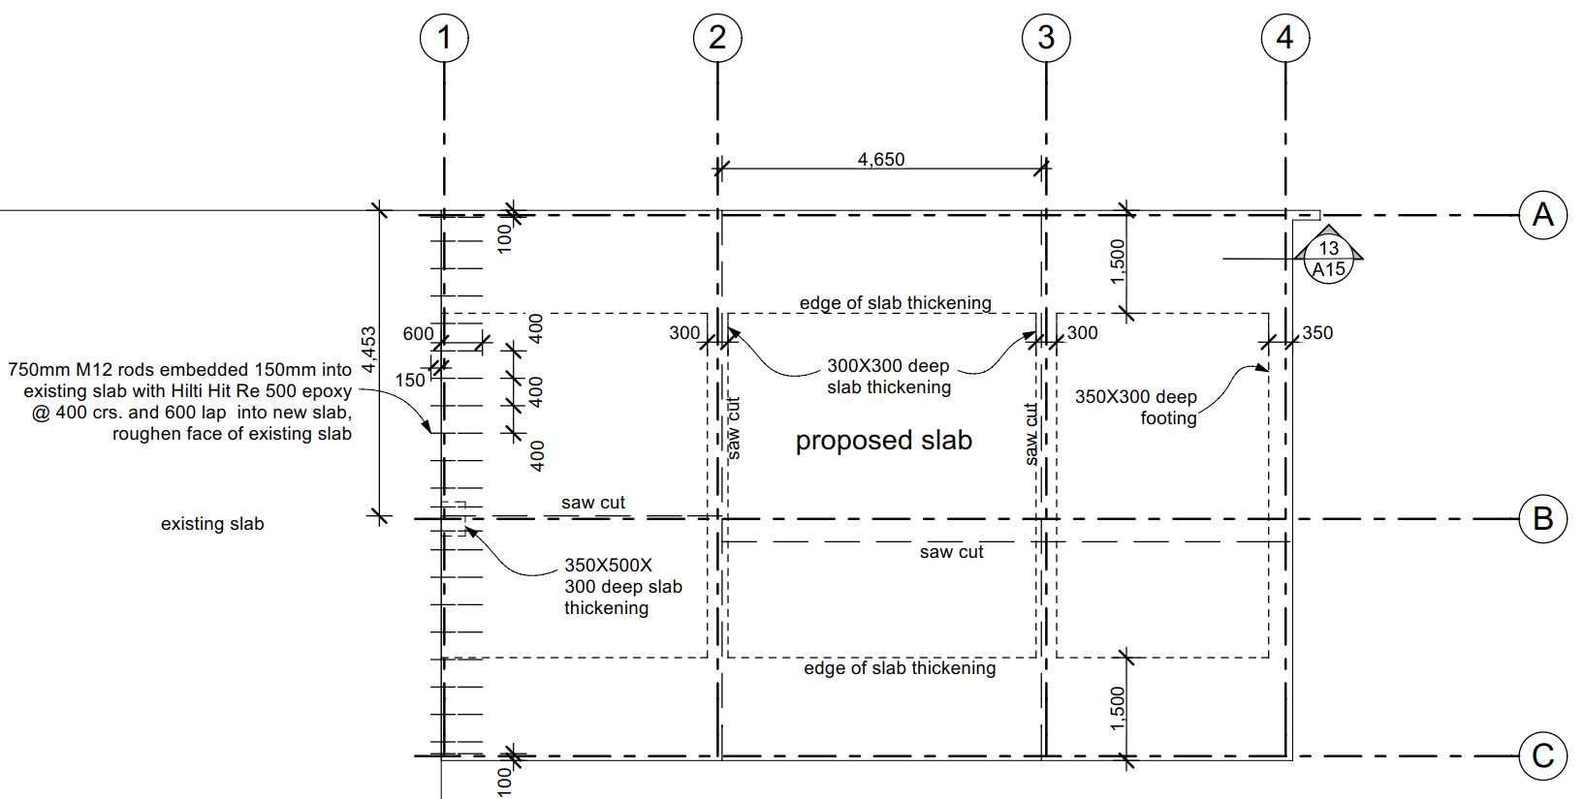
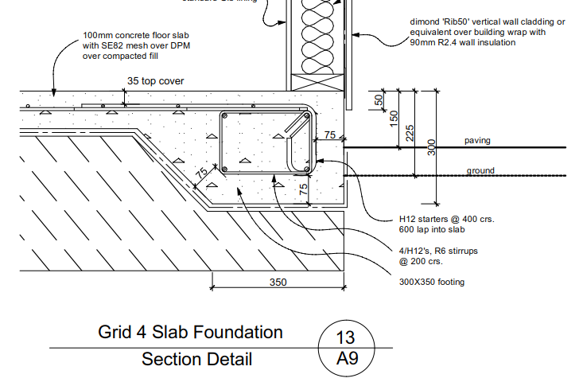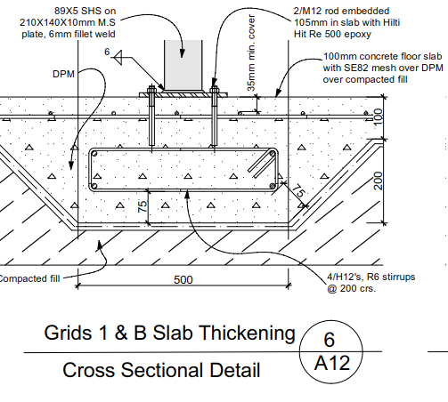
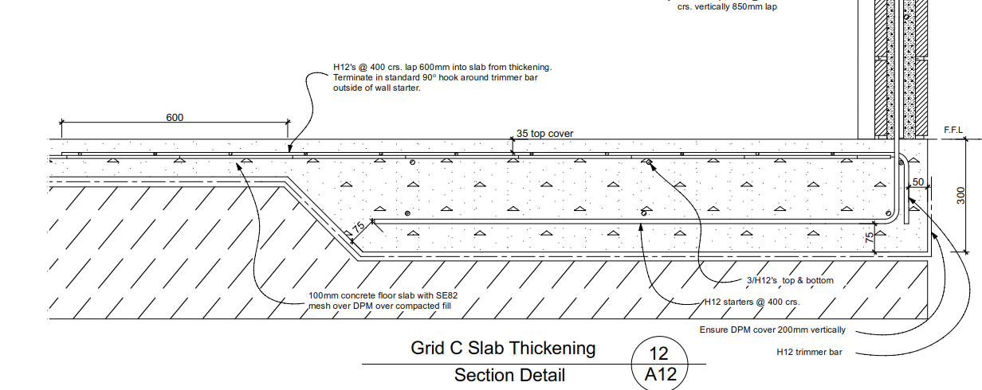
p.31 PS1 subject to safe bearing pressure of 50kPa or more (UBC 150kPa)
p.33 DFR, Structex 14 Dec 2016
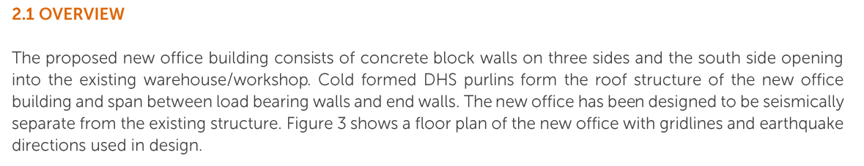
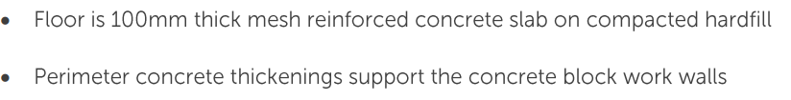
PLANS
Arch only

SPECS (arch)
2.4.1 excavation
Excavations down to firm undisturbed ground, and footings and foundations 200mm minimum into solid, except where shown otherwise.
Below slabs on ground the general intent is to excavate to a stable undisturbed subgrade (of 300 kPa ultimate bearing capacity).
As soon as excavation and filling is complete foundation material will be inspected by the Architect, and any changes to foundation widths/details will be directed.
2.4.2 Hardfill & Blinding
Hardfill under slabs on grade shall be 150mm of standard TNZ AP40 basecourse free of clay or organic matter compacted to 95% relative compaction in accordance with NZS 4402 Test 4.1.1.
RFI 5/4/17; 13/7/17 Response
- please provide Engco geotechnical report for 83 Byron St
Refer to the EDC Geotechnical report supplied within these documents
- Please compare foundation for existing building to the foundation for the proposed extension since the two will be structurally connected.
Refer to the structural calculations provided with the Structex engineering report supplied within these Documents.
- Specification section 2.4.1 Excavation states: “Below slabs on ground the general intent is to excavate to a stable undisturbed subgrade (of 300kPa ultimate bearing capacity).” This is inconsistent with the PS1 and the geotechnical letter which indicate the foundation was designed for a safe bearing of 50kPa (which I understand to be equivalent to an ultimate bearing capacity of 150kPa which was recommended by the geotechnical letter). Please amend specification.
Refer to Project specification document section 2.4.1
- Specification section 2.4.1 Excavation also states “As soon as excavation and filling is complete foundation material will be inspected by the Architect…”. Please amend specification for foundation subgrade to be verified by the geotechnical engineer.
Refer to Project specification document section 2.4.1
- Specification section 2.4.2 Hardfill & Blinding states “Hardfill under slabs on grade shall be 150mm of standard TNZ AP40 basecourse…” The geotechnical letter recommends a 300mm thick layer of AP65 below the concrete slab if placed on organic fill with UBC 150kPa, with geotextile (Bidim A19 or equal) on base & sides of excavation, geogrid (Cirtex Duragrid 30/30 or equal) over the textile; extending beyond the building footprint a distance equal to the depth of the gravel. Please address why geotechnical recommendations were not followed.
Refer to Project specification document section 2.4.2
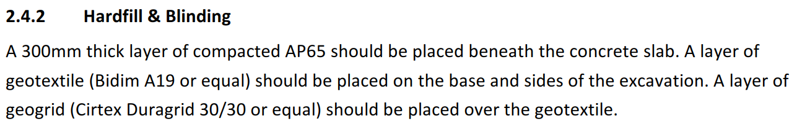
- The geotechnical letter also recommends that where it is not possible to extend the gravel layer beyond the building footprint on the South & West sides of the building because the site boundary does not does not provide adequate space, a new slab section must be designed. Please address this issue.
Refer to the structural calculations provided with the Structex engineering report supplied within these Documents.
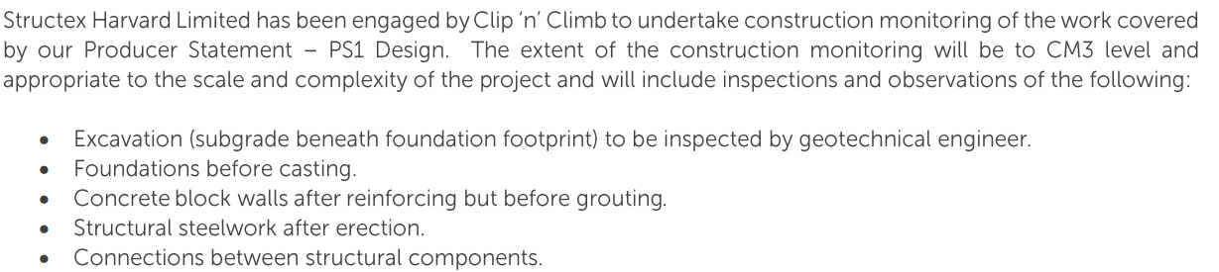
RFI ADDED 13/7/17
- Report not provided
- Withdrawn – DFR section 2.1 states office has been designed to be seismically separate from the existing structure
- Resolved
- Resolved
- Resolved
- Response refers to structural calculations; this does not answer the question. Please indicate where this information is found.
Response 31/7/17
Engco Geotechnical Report for 83 Byron st, Ref 16363, rev 1 30/1/2017, signed Andrew Lind, CPEng (civil/struct)
- Per EQC, moderate to severe liquefaction observed in the area (June 2011), minor (Dec 2011)
- EQC: no ground cracks or lateral spreading
- No EQ induced land deformation observed on site
- 2 CPTu to 15m, 4 DCPs to 2.0m, 2 HA to 2.0m, 1 CPT
- 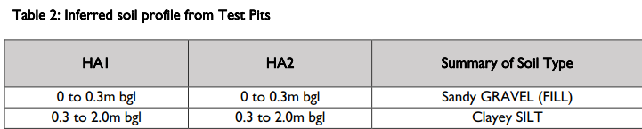
- GW not encountered in shallow investigation; GNS 0.0 – 1.0m
- For analysis, GW = 2.0 (in situ), 0.5m (design)
- Subsoil class D
- 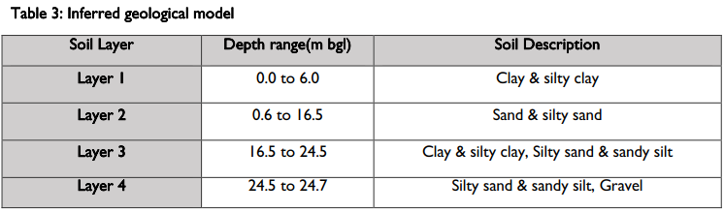
- 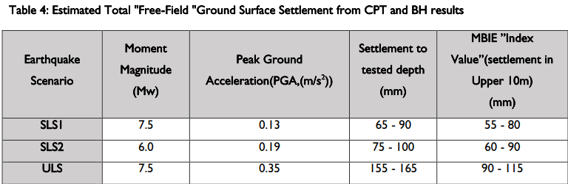
- Non-liq soil layer from 3.0m to 7.0m (ULS)
- Global lateral movement – minor to moderate
- Lateral stretch – minor to moderate
- Site sufficiently tested to SLS
- Conventional shallow fdn not recommended
- SED piled fdn founded at 12.5m
RFI 31/7/17
- ADDED 31/7/17: Please provide results of CPT and CPTu site investigation.
a2) ADDED 31/7/17: The Engco report for 83 Byron St indicates potential liquefaction induced settlement up to 100mm for SLS and up to 165mm for ULS are possible. Please clarify that this has been considered in design of the slab footing for 80 Byron St extension.
- 31/7/17: no response provided
Response 15/8/17
- ENGCO report provided

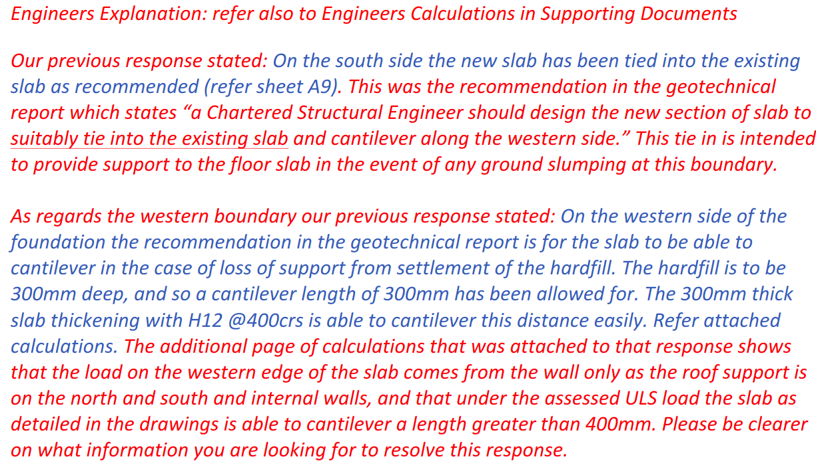
Geotechnical Report for proposed commercial building, ref 16363, 11/11/2016, Engco, signed Andrew Lind, CPEng (civil, Structural) & David Brierley, CPEng (management)
- 2 CPTu to 15m, 4 DCP to 2.0m, 2 HA to 2.0m, 1 CPT
- 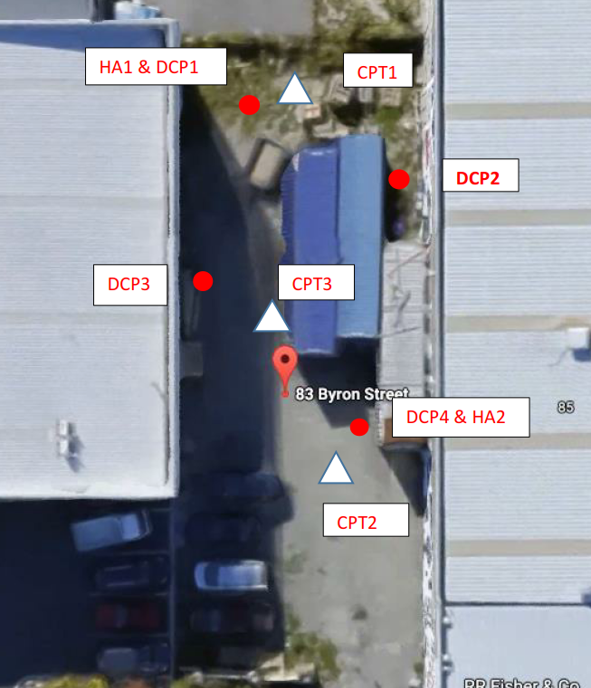
Re a.2) recommendations by Geotech letter were followed, therefore, liquefaction induced settlement should have been considered.

