Application for a building consent for the installation of a solid/liquid fuel heating appliance

Section 33 or Section 45, Building Act 2004, Form 2 - Building (Forms) Regulations 2004

About this form
- Please check that the forms that you are using are current at the time of application as forms are subject to change without notice.
- General information can be found on our website at
- A building consent is the formal approval issued by a Building Consent Authority (BCA) to ensure certain works meet the requirements of the Building Act 2004, Building Regulations and the New Zealand Building Code.

GENERAL INFORMATION:
- Application fees and charges: The latest Building Consents Fee Schedule is available on our website or from one of our Service Centres. A building consent will not be issued by the Council until all fees and charges relating to that consent application have been paid in full. When applying for a consent the costs/charges may vary depending on the time a building consent officer spends processing your consent. Further information could also impact on these costs and delay issuing of a consent.
- Guidance sheets and information booklets produced by the Council and the Ministry of Business, Innovation and Employment Building and Housing Group are available at all Service desks.
- For general enquiries please phone (03) 941 8999 or email info@ccc.govt.nz
- Christchurch City Council reserves the right, from time to time, to contact customers in regard to the services provided.

SUBMITTING AN APPLICATION:
Online Services applications:
- You can submit your application online at onlineservices.ccc.govt.nz
- You will need to register to use Online Services. You can register at onlineservices.ccc.govt.nz
An application can also be lodged via the following methods:
- Post (additional costs apply) your application to: Consenting & Compliance Group, PO Box 73013, Christchurch 8154
- Hand delivered (additional costs apply) to Civic Offices, 53 Hereford Street, Christchurch Central or dropped off at any Council service desk listed on our website at www.ccc.govt.nz/contact-us/service-desks.

All applications will be checked for completeness prior to acceptance. Please ensure that you have compiled your documents carefully to avoid delays in accepting your application. If your application is incomplete it will not be accepted and the statutory processing timeframe will not start until the missing information has been provided and resubmitted.

Items marked * are mandatory for all applications.
1. The building

Street address of building:*(for structures that do not have a street address, state the nearest street intersection and the distance and direction from that intersection)
15A CLYDE ROAD, RICCARTON

Legal description of land where building is located:*(state legal description as at the date of application and, if the land is proposed to be subdivided, include details of relevant lot numbers and subdivision consent)
Lot 2 DP 41440

Building name:

Location of building within site/block number: (include nearest street access)

Number of levels:* (including ground level and any levels below ground) |  | Level/unit number:
2

Area: (total floor area; indicate area affected by the building work if less than the total area)
Total floor area:* | Existing floor area: | New floor area:
500SQM

Current, lawfully established, use:*(include number of occupants per level and per use if more than 1) |  | Year first constructed:
RESIDENTIAL

2. The owner

Name of owner:*(include preferred form of address, e.g. Mr, Mrs, Ms, Miss, Dr if an individual)
WINSOME DORMER

Contact person: (must have a New Zealand address)
WINSOME DORMER

Mailing address:*
15A CLYDE ROAD, RICCHARTON

Street address/Registered office: (if different than above)

Phone number:
Landline: | Mobile: | Daytime: | After hours: | Fax:
 | 021325389

Email address: |  | Website:
wdormer@xtra.co.nz

The following evidence of ownership is attached to this application:(copy of certificate of title, lease, agreement for sale and purchase, or other document showing full name of legal owner(s) of the building)

A recent copy of certificate of title(s) (less than six months old) and where applicable the following:
Lease Agreement for sale and purchase Licence or property management agreement

Certificate of title(s) are available from the Christchurch City Council for a fee. Required? Yes No
3. Agent

Name of agent: ( only required if application is being made on behalf of the owner)
Gas Unlimited

Contact person: (must have a New Zealand address)
Greg Smith

New Zealand Companies Registered Number: (If applicable - Refer to www.business.govt.nz/companies )
2115431

Mailing address:
PO Box 5575 Papanui, Christchurch

Street address/Registered office: (if different than above)
34 Sawyers Arms Road, Papanui, Christchurch 8052

Phone number:
Landline: | Mobile: | Daytime: | After hours: | Fax:
03 3523838 | 0274 777200

Email address: |  | Website:
greg@gasunlimited.co.nz

Relationship to owner: (state details of the authorisation from the owner to make the application on the owner’s behalf)
Agent

First point of contact for communications with the council/building consent authority: ()
Agent | Owner | Other: (if other specify whom and provide contact details as per above)

4. Application
*I request that you issue a project information memorandum / project information memorandum and building consent /
building consent for the building work described in this application.

This application is for: | (write building consent or approval number below)
Amendment to building consent:

I wish to receive my building consent/PIM and approved documentation in the following format:

Electronically via Online Services
Email – Email address(es):
CD |  | The CD or hard copy documents are to be collected from:
Hard copy (additional costs apply)

All consent related invoices/refunds to be billed and posted to: Owner Agent
(Please note: any refunds are paid to the receipted name unless written authorisation has been received from the receipted person or company)

All of the included information on this form is, to the best of my knowledge, true and correct. I understand that all plans, documentation and reports submitted as part of an application are required to be kept available for public record, therefore the public (including business organisations and other units of the Council) may view this application, once submitted.

I / we understand that no work is to commence until the building consent is issued.

Signature of owner/agent:*  (on behalf of and with the authority of the owner) |  | 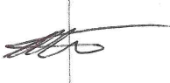
Date:* | 2.3.2022
Print name: | Greg Smith

If you are signing this application on behalf of a company/trust/other entity (the applicant), you are declaring that you are duly authorised to sign on behalf of the applicant to make such an application.
By signing this application you are accepting responsibility to pay all actual and reasonable costs incurred by the Christchurch City Council. Where an invoiced amount has not been paid by the stated due date, the Council may commence debt recovery action. The Council reserves the right to charge interest, payable from the date the debt became due, and recover costs incurred in pursuing recovery of the debt.

PRIVACY INFORMATION:
Please refer to Council's website privacy statement:
www.govt.nz/about/termsofuse/privacystatement
If you would like to request access to: or correction of; your details, please contact the Council.

5. The project

Description of the building work:*
INSTALLATION OF WOOD FIRE

Make: | Model: | Clean air certification no:
MASPORT | RANGITATA | 203666

The appliance is: New Second hand ^{(1) see Advisory Notes}
The installation type is: In-built Insert Free standing
The fuel type is: Wood Multi fuel Wood pellets Coal Diesel/Diesel blend

The appliance is fitted with re-circulation fan: Yes No

Does the existing or proposed installation involve a wetback?
No Yes - state the name and address of the certifying plumber who will disconnect and/or install the wetback:

Name (individual): | Address: | License number:

When a new hot water booster or wetback is being installed, an anti-scalding device must be fitted in the supply from the cylinder to the sanitary fixtures. This requirement does not apply if an existing hot water booster or wetback is being replaced, or is existing elsewhere in the hot water system. The hot water cylinder must be open vented.

Please confirm that an anti-scalding device will be fitted if this is a new wet back connection: Yes

Is this replacing an existing operational solid fuel burning appliance:
Yes- | confirm the age of the existing solid fuel burning appliance (to the nearest year), and provide Building Consent number (if known) for the installation of the operational solid fuel burning appliance:
No - | please provide the resource consent number from Environment Canterbury (ECan) (applies to wood, wood pellet or coal burning appliances only):

Estimated value of appliance and installation (incl. GST): | $ 5000.00

Refer to ECan’s website to note if a particular solid fuel burning appliance has been approved:
www.ecan.govt.nz/data/authorised-burners/

6. Restricted building work

Will the building work include any restricted building work?* Yes No
(e.g. Alterations to the primary structure or external moisture management system. Note - forming a new penetration through roof cladding larger than 300mm or alterations to rafters, joist and trusses are considered restricted building work)
If Yes, provide the following details of all licensed building practitioners who will be involved in carrying out or supervising the restricted building work. (If these details are unknown at the time of the application, they must be supplied before the building work begins.)

Designer or Architect:
Name of LBP: |  | Registration or LBP number:
Licensing class: |  | Certificate of design work attached? | Yes
Structural Engineer:
Name of LBP: |  | Registration or LBP number:
Licensing class: |  | Certificate of design work attached? | Yes
Builder/Carpentry work:
Name of LBP: |  | Registration or LBP number:
Licensing class: |  | Record of building work attached? | Yes
Roofing:
Name of LBP: |  | Registration or LBP number:
Licensing class: |  |  | Yes
Note: Continue on another page if necessary.

7. Building consent

The following plans and specifications are attached to this application:*
FLOOR PLAN

The building work will comply with the building code as follows:
Clause  (select relevant clause numbers of building code) | Means of compliance  (refer to the relevant acceptable solution or verification method or detail of alternative solution in the plans and specifications) | Waiver/Modification required  (state nature of waiver or modification of building code required)
B1 - Structure
B2 - Durability | AS/NZ2918:2001
C1-6 - Protection from Fire
E2 - External Moisture | E2/AS1
F3 - Hazardous Substances and Processes
F7 - Warning Systems | F7/AS1
G9 - Electricity
G10 - Piped Services
G11 - Gas as an Energy Source
G12 – Water Supplies

8. Attachments

The following documents are attached to this application:
Floor plan of the installation - a floor plan of the building showing the proposed siting of the heater and smoke alarms (refer to section B in the Appendix).
Third Party Statement/report on condition of chimney - Insert or inbuilt installation, verify existing structural integrity of existing fireplace/chimney include photos (check suitability of appliance to be installed in chimney, e.g. AS/NZS2918 appendix E).
For earthquake damaged chimney repairs: Refer to MBIE guidance repairing and rebuilding houses affected by the Canterbury earthquakes - www.building.govt.nz/building-code-compliance/canterbury-rebuild/- appendix A3.
Manufacturer’s specifications/installation instructions - full set of manufacturer’s specification and installation instructions for both the appliance and flue system.
Test certificate - from recognised testing agency (only required if appliance is an alternative system to AS/NZS2918).
Cross sections and flashing details (as per advisory information below).
Second-hand appliance test certification from manufacturer or authorised manufacturer’s agent.
Memoranda from licensed building practitioner(s) who carried out or supervised any design work that is restricted building work.
Copy of authorisations from Regional Authority (e.g. ECan).

A. Additional Information

Earthquake related work:

Is this application earthquake related?
No
Yes
If yes, is it coordinated by an insurance company via a project management organisation (PMO), e.g. Arrow, Fletchers, etc?
No
Yes - name of PMO:

B. Advisory notes for solid/liquid fuel heaters

Provide the following information where applicable:
Full floor plan (scaled or dimensioned) of all floors showing:
- Location of the heater (existing location also if different from proposed).
- Location of all walls, windows and doors, with all rooms named (for all floors).
- Location of existing/proposed smoke alarms (that comply with the relevant standards including having a “hush” facility); they must be marked with on the floor plan (refer to B-311 for guidance on smoke alarms locations). Smoke alarms will be inspected and tested prior to the issue of the code compliance certificate. Note: If the property has a sleep-out, the sleep-out is also required to have smoke alarms fitted.
- Location of the existing water cylinder if a wetback/hot water booster is to be fitted.
- Flue Height: The minimum flue heights specified in AS/NZS 2918:2001 (Solid Fuel/Liquid Fuel Heaters) or the manufacturer’s installation instruction may be insufficient if combustion problems and smoke or odour nuisance are to be avoided. Consideration should be given to extending the flue height above those required by the manufacturer or AS/NZS 2918:2001.
Note: If the flue height exceeds 1.2m above the roofline, consideration needs to be given to NZ Building Code performance B1.3.3.
The flue will need lateral bracing to withstand wind-load. If applicable please include details of complying bracing.

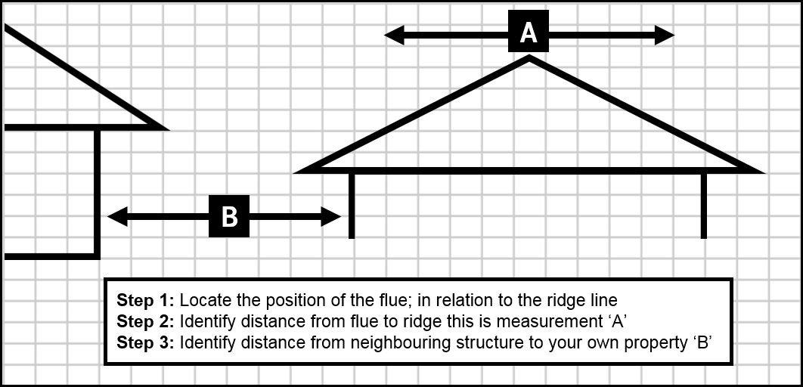

- Insert or inbuilt installation: Third party statement/report on condition of chimney
Please provide verification of the structural integrity of the existing fireplace/chimney where the installation involves an insert or inbuilt type appliance. Verification includes a report from a suitably qualified or competent person and could including photos, etc.

For earthquake damaged chimney repairs: Refer to Ministry of Building Innovation and Employment (MBIE) guidance document on repairing and rebuilding houses affected by the Canterbury earthquakes - www.building.govt.nz/building-code-compliance/canterbury-rebuild/ Appendix A3 page A3.1.
Provide cross section details where applicable:
- Cross section through building showing flue penetration through floor joists/fire protection (only required if the flue penetrates through an intermediate floor and the building is two or more stories in height.
- Cross section through building showing roof material and flashing details of the flue (only required if flue penetration is new).

Second hand solid/liquid fuel burners cannot be installed unless:
- A current clean air approval label is attached to the appliance (not applicable to some minor rural areas of Christchurch).
- Written evidence is provided to show that the appliance meets Building Code requirements. (An acceptable method is a satisfactory report from the manufacturer or manufacturer’s agent.)
- A new inner flue is required in all cases.

Liquid fuel storage:
- Show type of fuel (e.g. diesel, home blend, kerosene), size and location of the fuel storage tank in relation to the building and site boundaries. Wall openings (windows or doors) and wall cladding material within one metre of the storage tank should be shown (including neighboring properties).
Certification that the storage tank compiles with AS1692.

