THE RESOURCE MANAGEMENT ACT 1991

SECTION 221 (3) CANCELLATION OF CONSENT NOTICE

PURSUANT to section 221 (3) of the Resource Management Act 1991, the FAR NORTH DISTRICT COUNCIL hereby consents to the cancellation of Consent Notice CONO7056308.3 insofar as it relates to CT-273757, CT-273760, CT-273761, CT-273762, CT-273764, CT-273772, CT-273773, CT-273781, CT-298403, CT-298404, CT-298408, CT-298409, CT-298412.

SIGNED: 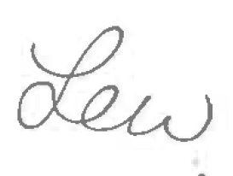
Mrs Louise Wilson - Authorised Officer
By the FAR NORTH DISTRICT COUNCIL
Under delegated authority:
TEAM LEADER – RESOURCE CONSENTS

DATED at KERIKERI 10-Aug-2018

