8 November 2021  NBA Christchurch One Limited  13 Jacksons Road  Merivale  Christchurch 8014 | 03 941 8999  53 Hereford Street  Christchurch 8011  PO Box 73013  Christchurch 8154  ccc.govt.nz

Dear Sir/Madam

Compliance schedule information
WOF/2020/5827
80 Byron Street Sydenham

As you are the new owner of the above property, we are sending you the compliance schedule for this building. A copy of this schedule needs to be kept onsite.

The specified systems listed on the schedule will need to be inspected, maintained and records kept on maintenance for the purposes of this building’s warrant of fitness.

The current warrant of fitness for your building expires on 1 August 2022. Next Year, the council will send you a reminder letter approximately one month before expiry. From there, under section 108 of the Building Act 2004, you will need to send the council a signed copy of your Building Warrant of Fitness (Form 12), along with a copy of the relevant Certificates of Compliance (Form 12As). You need to immediately engage with a BWOF agent or IQP (Independent Qualified Person) to do the inspection, maintenance and reporting.

The building warrant of fitness must be displayed in a public place in the building.

You are welcome to update your contact details with us at buildingwof@ccc.govt.nz. If you would like to talk to us, you can call me on the number below.
Yours sincerely
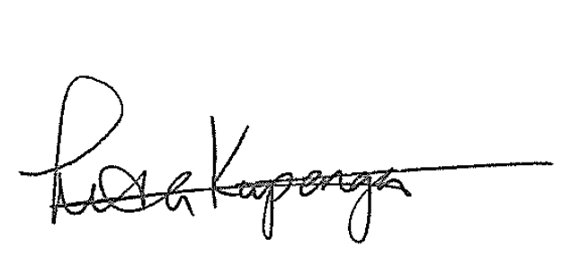
Lisa Kupenga
Building Officer Warrant of Fitness
03 941 6597

