25 January 2022

Freddie Ah Kuoi and Margot Lee Ah Kuoi
5 Waianga Place
RD 3
Kaikohe 0473

Reference Number: | EXM-2022-22/0
Property Address: | 5 Waianga Place, Omapere 0473
Property ID # | 3328070
Description: | Existing porch to be enclosed to join the 18m2 and 36m2 buildings and relocate exterior entry doors to enable the two buildings to become one residential dwelling.

Dear Sir / Madam,

Exemption to the Requirement for a Building Consent

Your application for an exemption to the requirement for a Building Consent has been approved and your property file has been updated accordingly.

The exemption has been approved in accordance with:

2 Territorial and regional authority discretionary exemptions

Any building work in respect of which the territorial authority or regional authority considers that a building consent is not necessary for the purposes of this Act because the authority considers that —

- The completed building work is likely to comply with the building code

If you have any questions please contact the Building Compliance Team on 0800 920 029 or 09 401 5200
Yours sincerely,
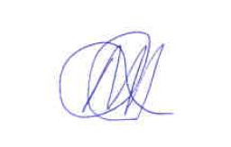
Michelle Ashdown
Building Compliance Officer
District Services

